Sprint 3 Plan

Web Audio Editor

***Sprint 3.0. 24 July, 2017***

***Document Revision v1.0. 18 July, 2017***

Team 5

CMPS115-01

Dan Suh, Hyejin Lee, Minkyu Yun, Seungchyul Shin, Sunjae Lee

## Goal

Build fundamental audio editing functionalities:

1) add noise cancelling functionality

2) login authentication system

3) save personal settings

4) insert transparent digital audio watermarks

5) insert sound effect

## Task listing, organized by user story

### User Story 1

*As a user, I want to add noise cancelling functionality to my audio file*

Task 1: Search and study about noise cancelling (3 hours)

Task 2: Decide which noise cancelling method to use (1 hour)

Task 3: Add a button to reduce noise of audio files (1 hour)

Task 4: Implement noise cancelling function in backend (5 hours)

Task 5: Adjust noise cancelling function into the audio file (3 hours)

Total for user story 1 : 13 hours

### User Story 2

*As a user, I want to have login authentication system*

Task 1: Add a icon for login and sign up (1 hour)

Task 2: Implement login authentication system (4 hours)

Total for user story 2 : 4 hours

### User Story 3

*As a user, I want to save my personal settings*

Task 1: Save personal settings according to login accounts (4 hours)

Task 2: Call personal settings according to login accounts (1 hour)

Total for user story 3 : 5 hours

### User Story 4

*As a user, I want to insert my own transparent digital audio watermarks into my audio file*

Task 1: Add buttons for creating watermarks and inserting into audio file (1 hour)

Task 2: Allow to create watermarks on user’s own (1 hour)

Task 3: Add functions to insert own watermarks into audio file (3 hours)

Total for user story 4: 5 hours

### User Story 5

*As a user, I want to insert sound effect*

Task 1: Add a button to insert sound effect (1 hour)

Task 2: Apply sound effect changes into audio file (3 hours)

Total for user story 5 : 4 hours

## Team roles

**Dan Suh** Product Owner, Developer

**Hyejin Lee** Developer

**Minkyu Yun** Developer

**Seungchyul Shin** Scrum Master, Developer

**Sunjae Lee** Developer

## Initial task assignment

**Dan Suh** User Story 1, Task 1

**Hyejin Lee** User Story 2, Task 1

**Minkyu Yun** User Story 3, Task 1

**Seungchyul Shin** User Story 4, Task 1

**Sunjae Lee** User Story 5, Task 1

## Initial burnup chart

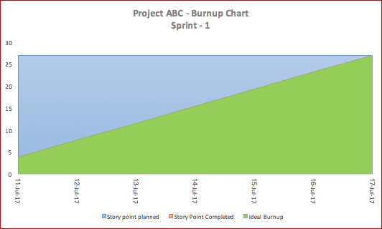

## Initial scrum board

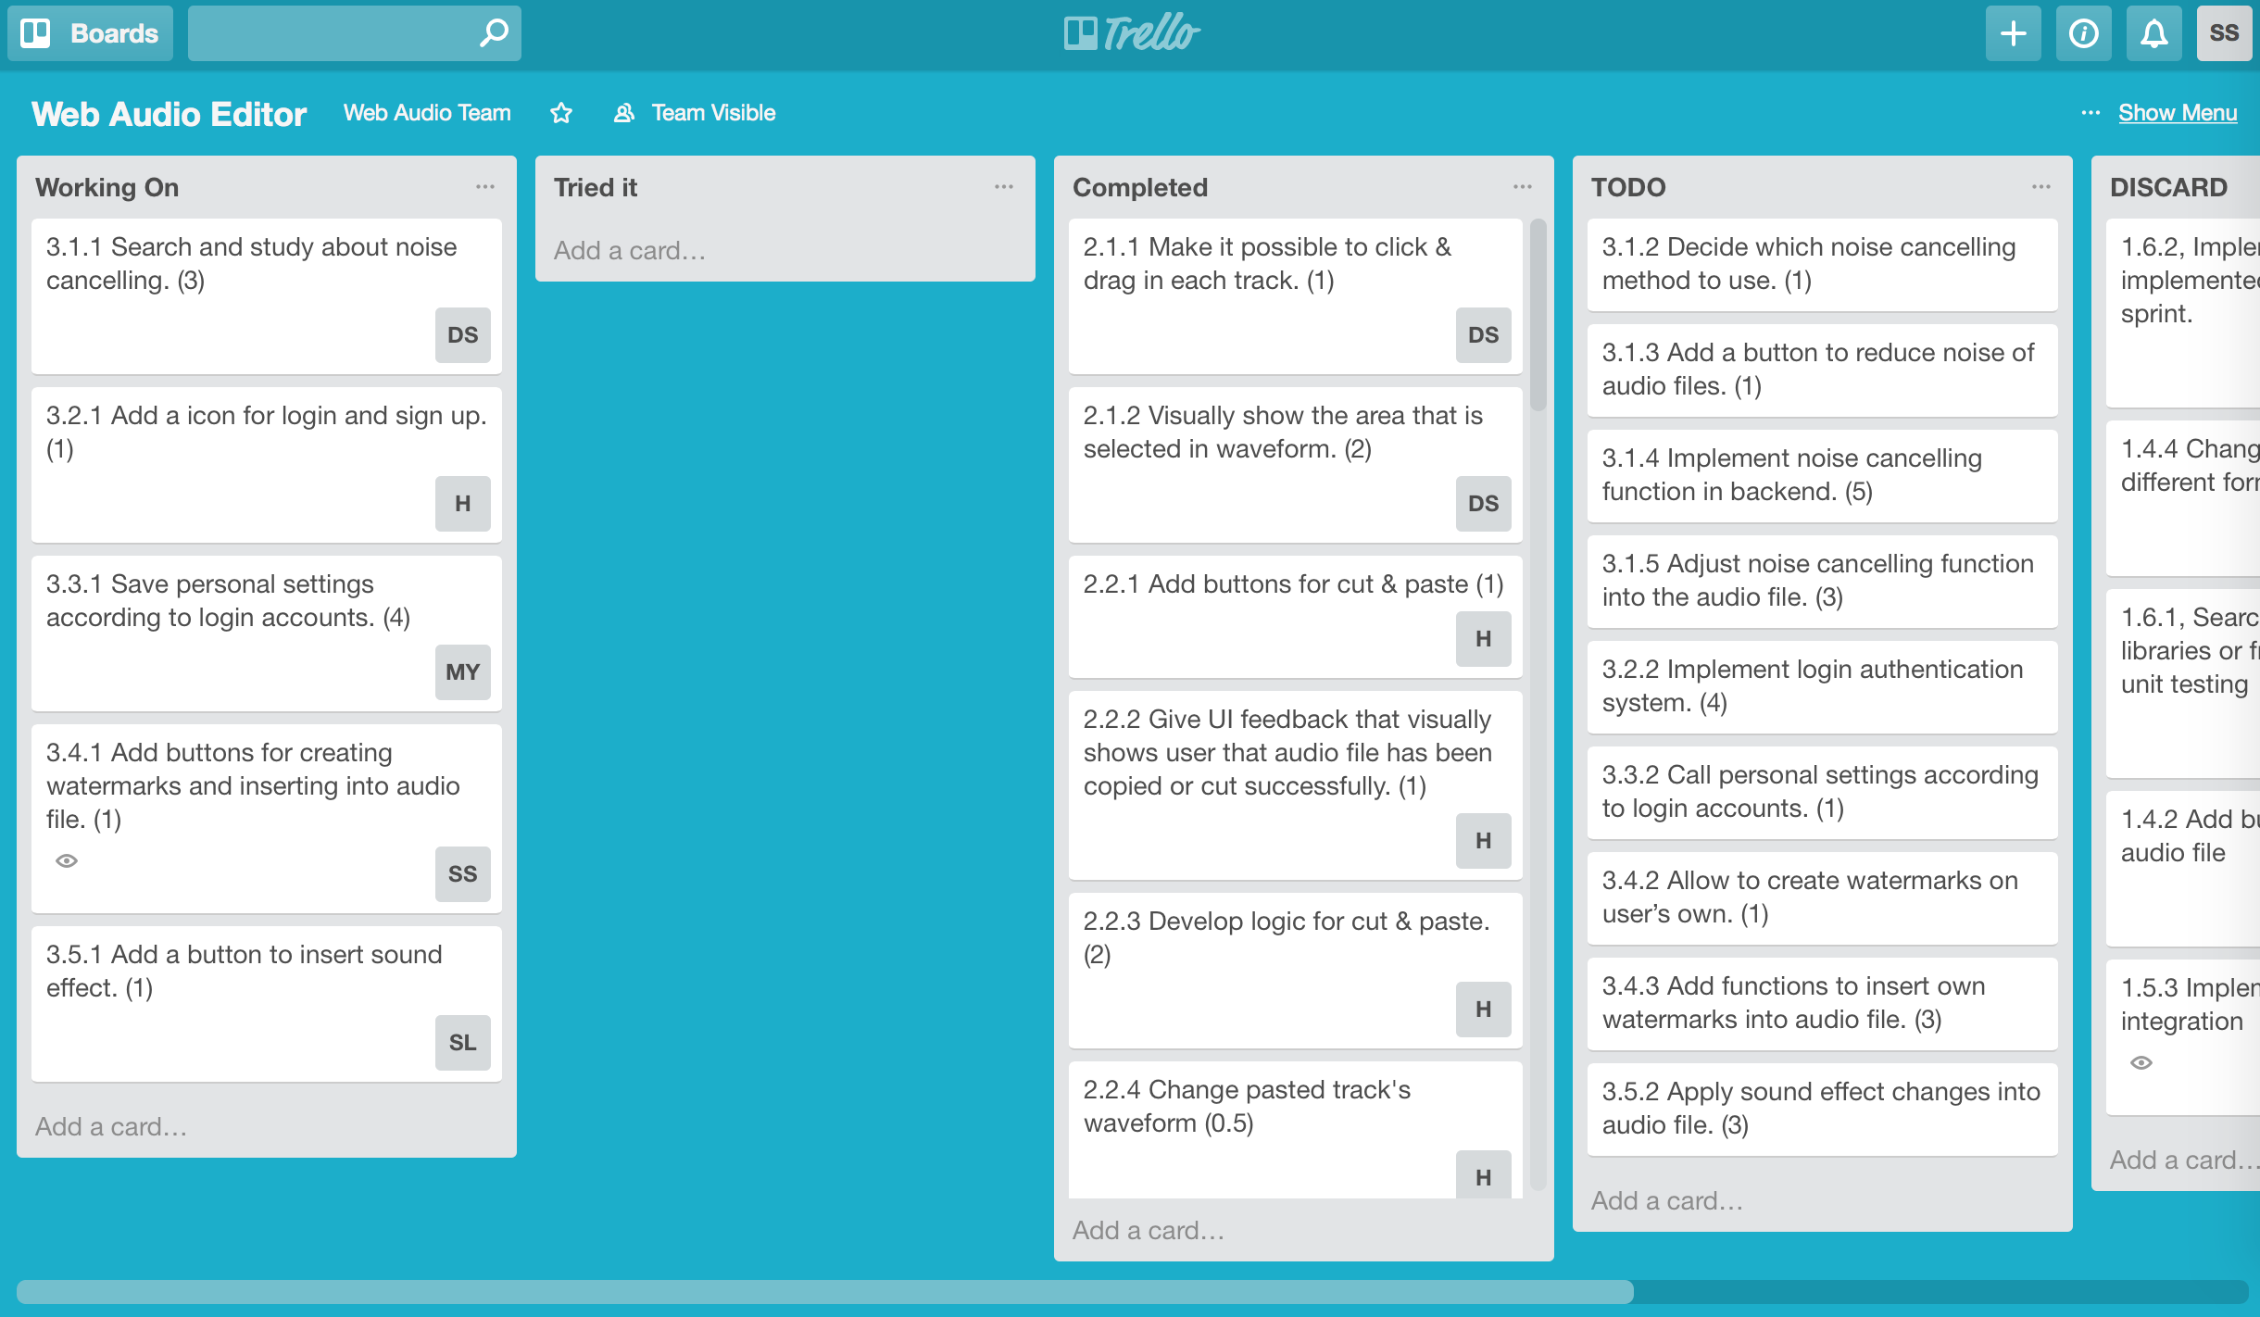

## Scrum times

**Monday** 14:20 ~ 14:40 (TA)

**Wednesday** 14:20 ~ 14:40 (TA)

**Saturday** 08:45 ~ 09:00